|  |  |  |  |  |  |
| --- | --- | --- | --- | --- | --- |
| Date | 23-Nov-22 | | | Tester Name | Mohammad Yusuf |
| Environment | Penfax - Test | | | Login used |  |
| Operating System | Windows | Version: | Update: | | |
| Software Used | Select Software | Version: | Update: | | |
| Select Software | Version: | Update: | | |
| Release version |  | | | | |
| Title |  | | | | |
| Test Type | Regression | | | | |
| Test Scenario |  | | | | |
|  |  | | | | |
| Expected Results |  | | | | |
| Pass/Fail | Select | | | JIRA# | N/A |

Describe your steps with screenshots:

Precondition: Member is on Leave

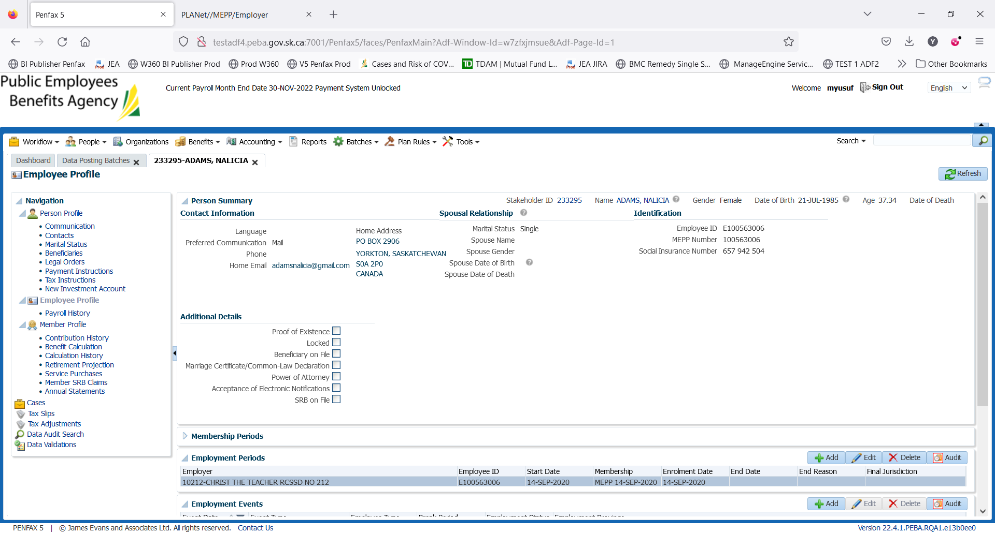

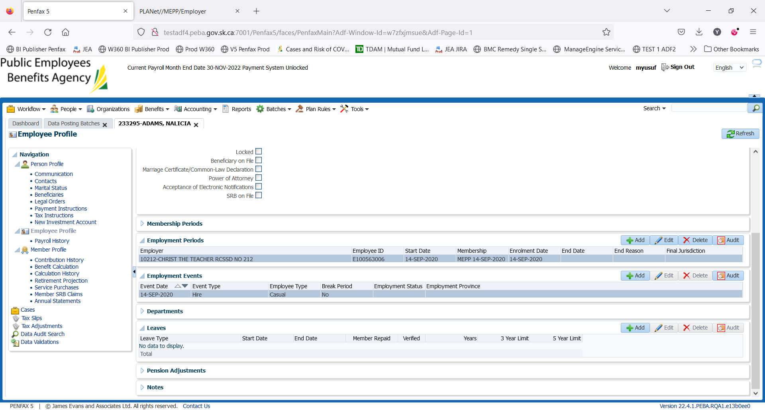

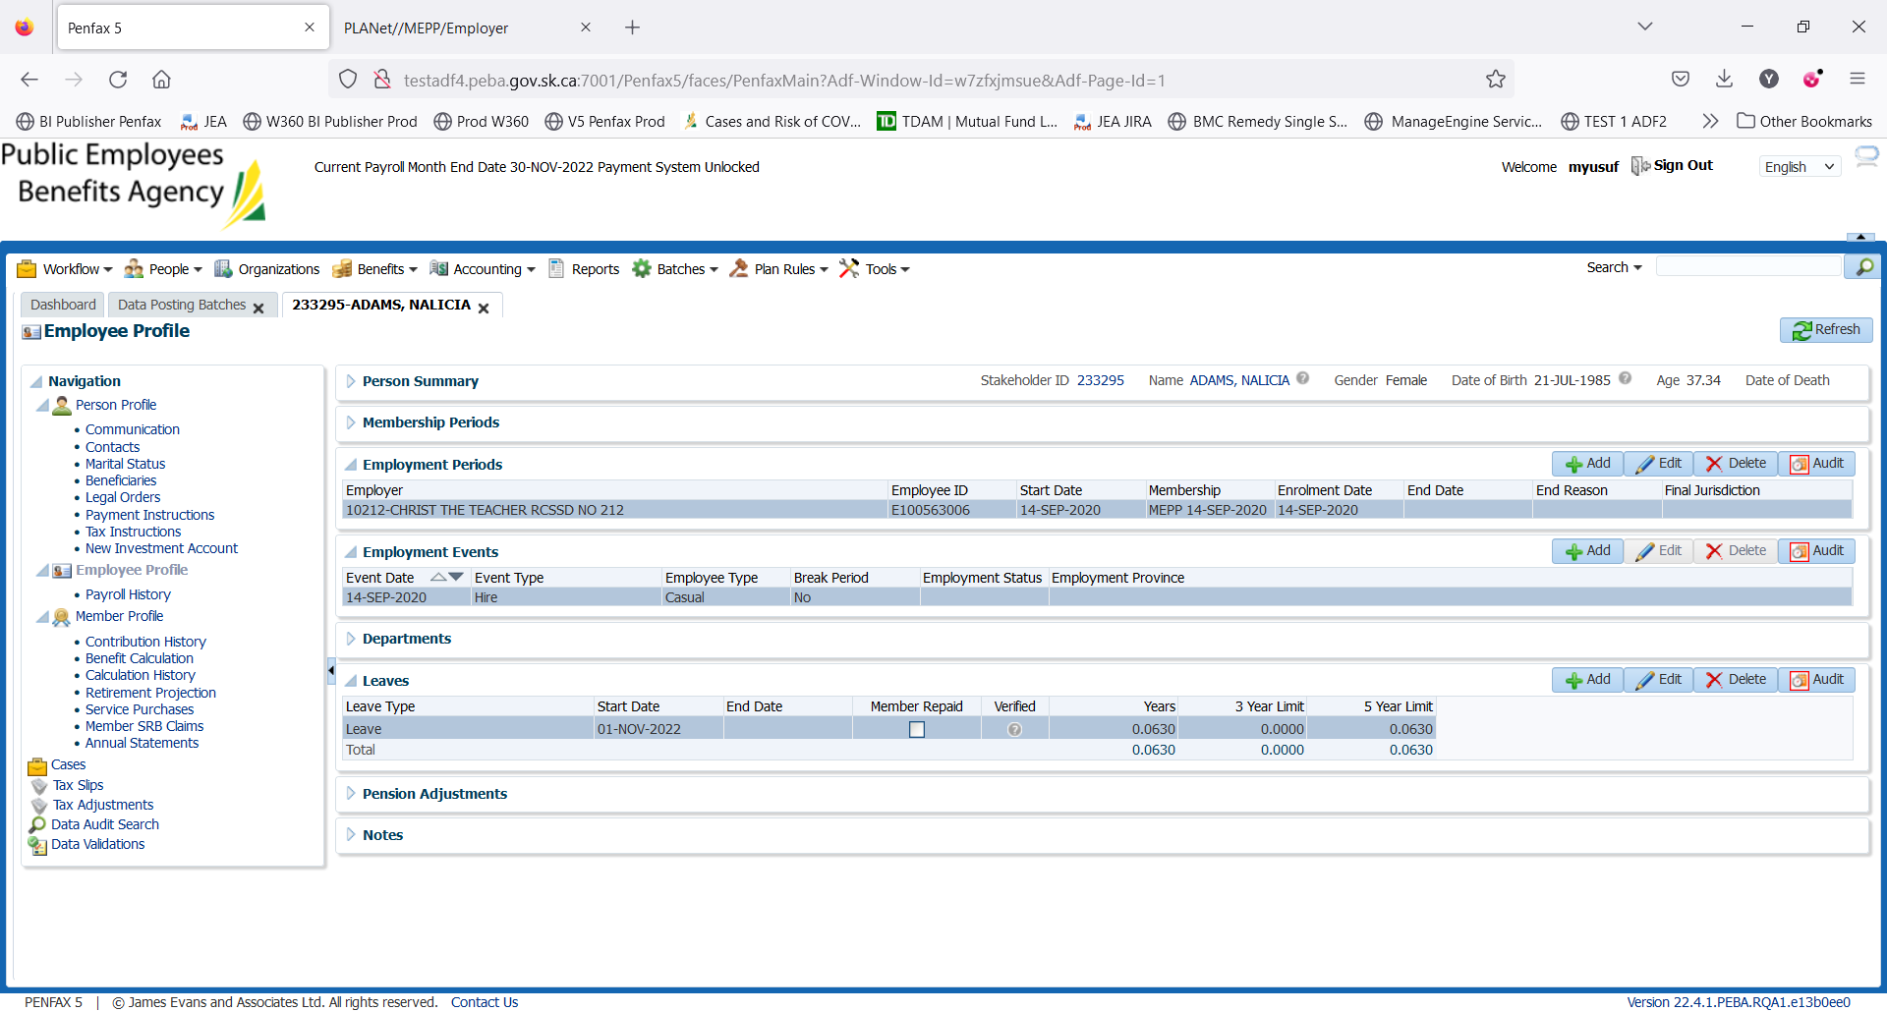

The precondition is fully filled. Member is on Leave as of Nov 01, 2022

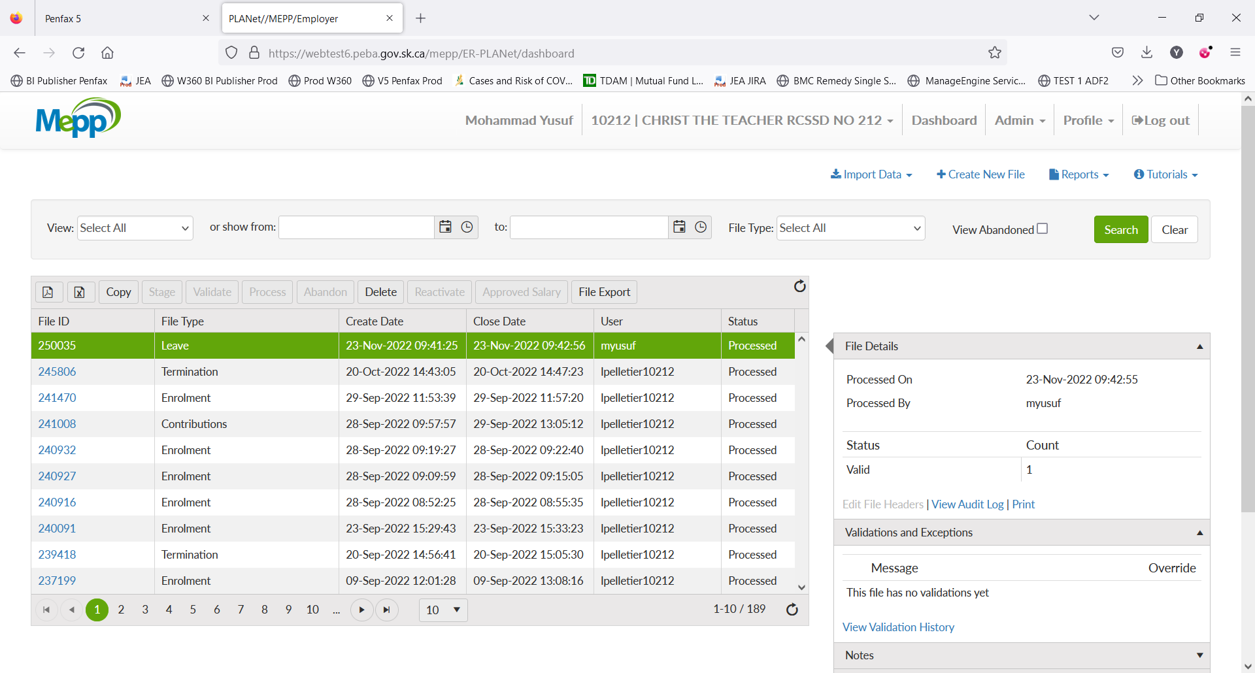

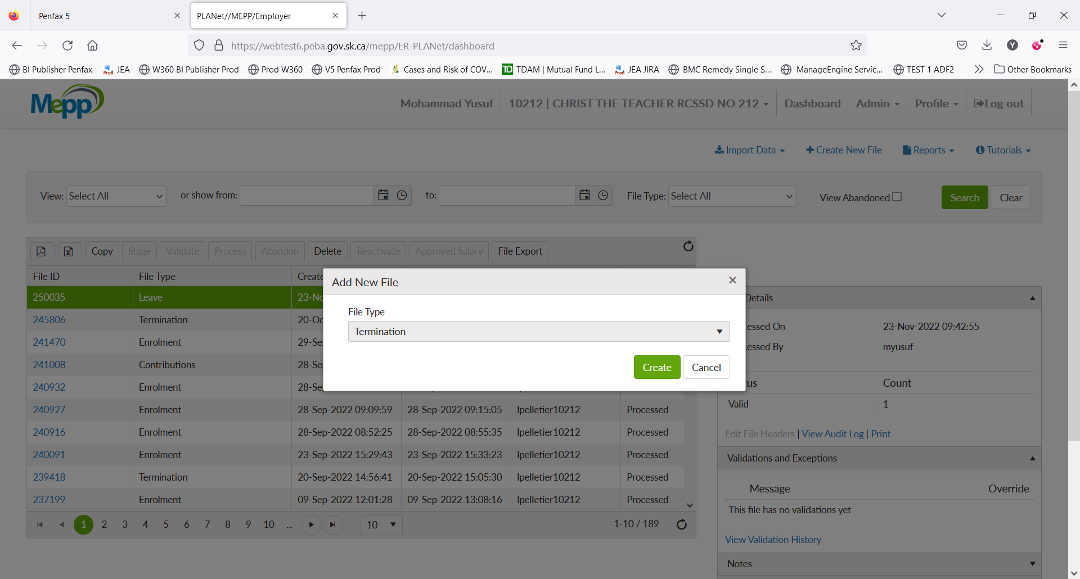

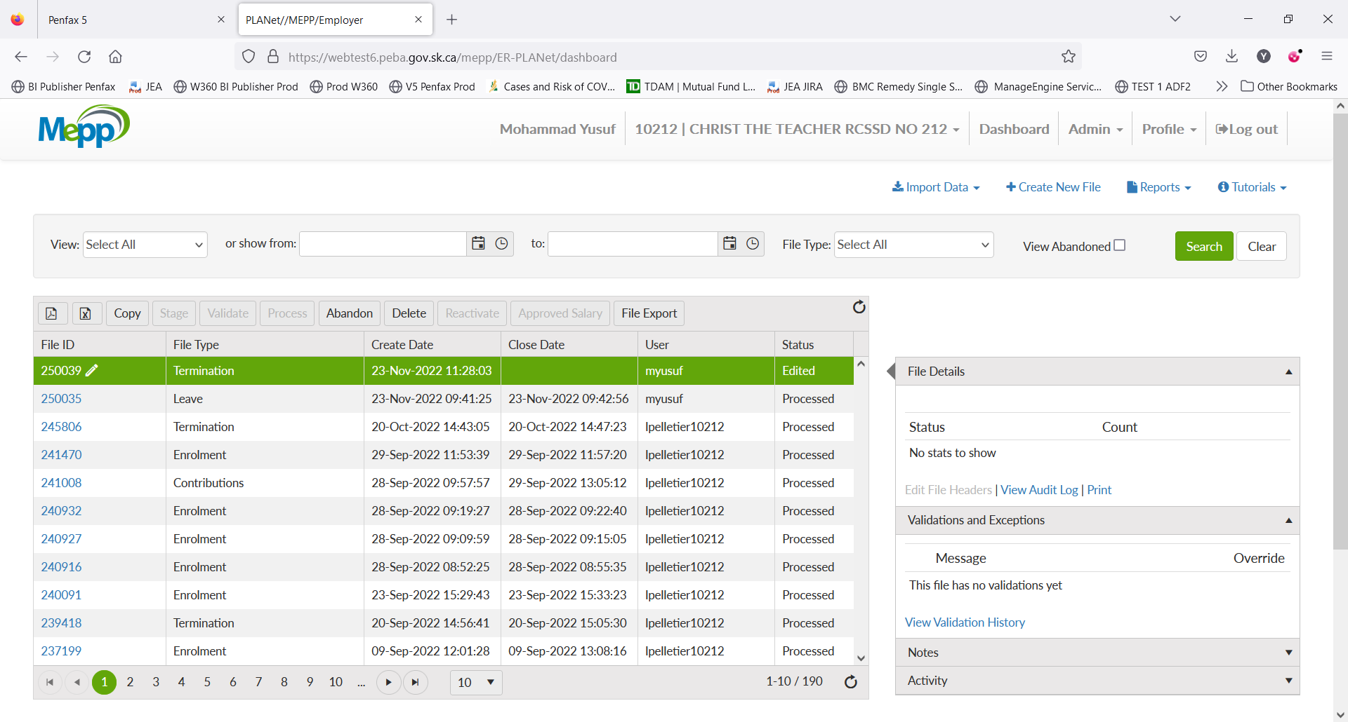

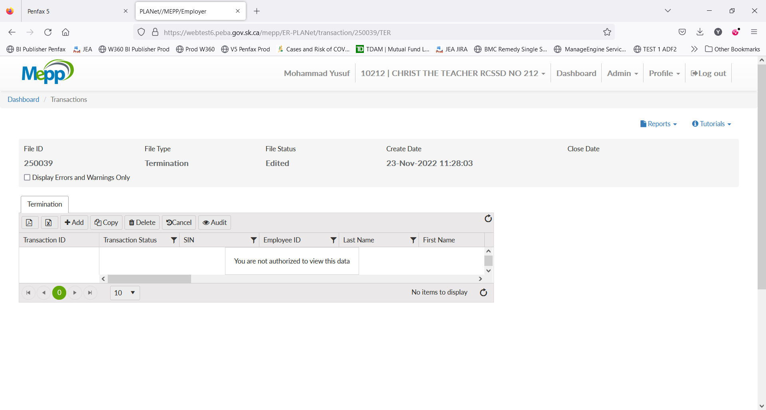

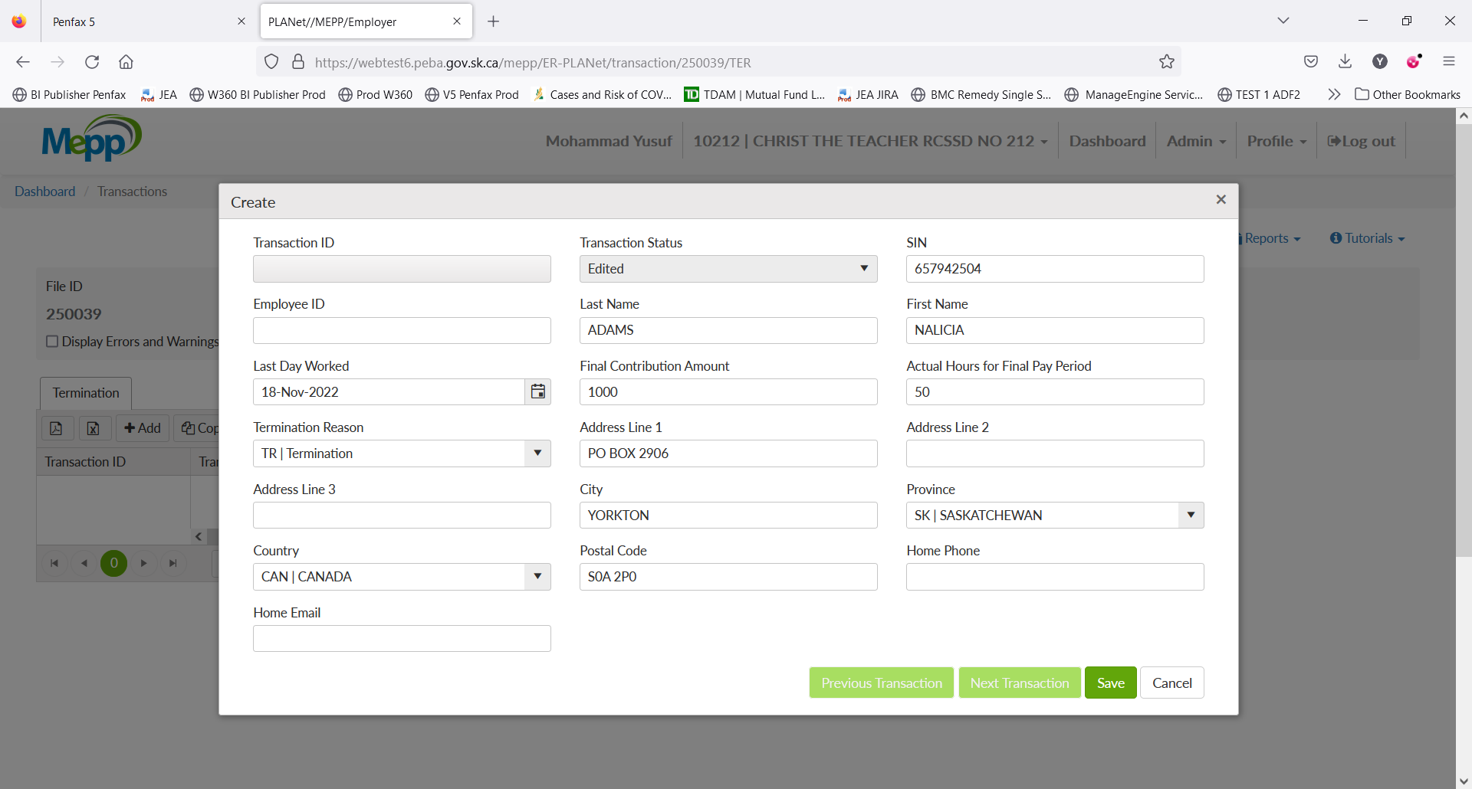

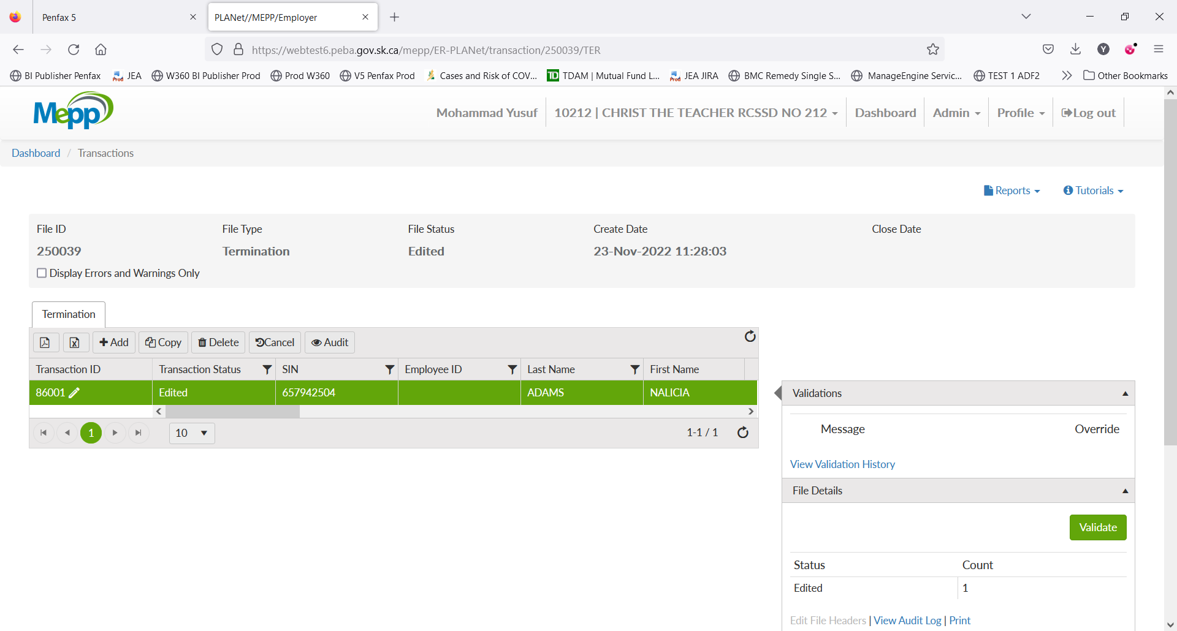

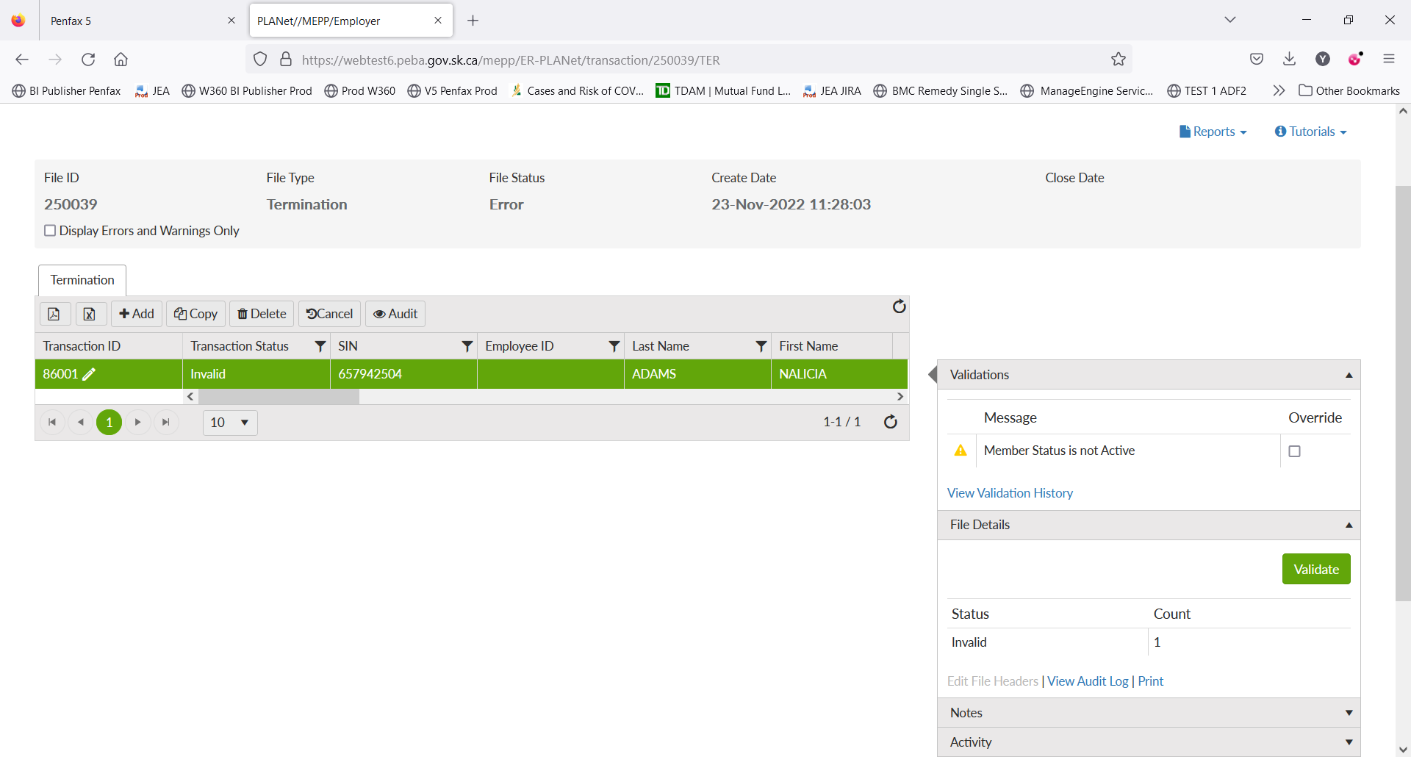

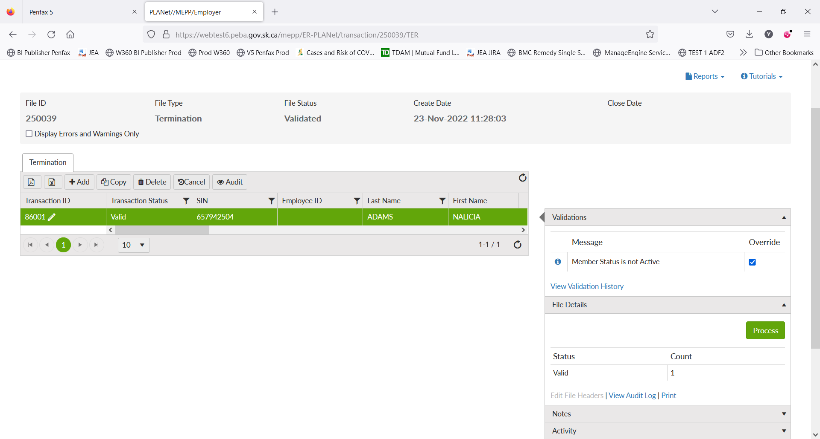

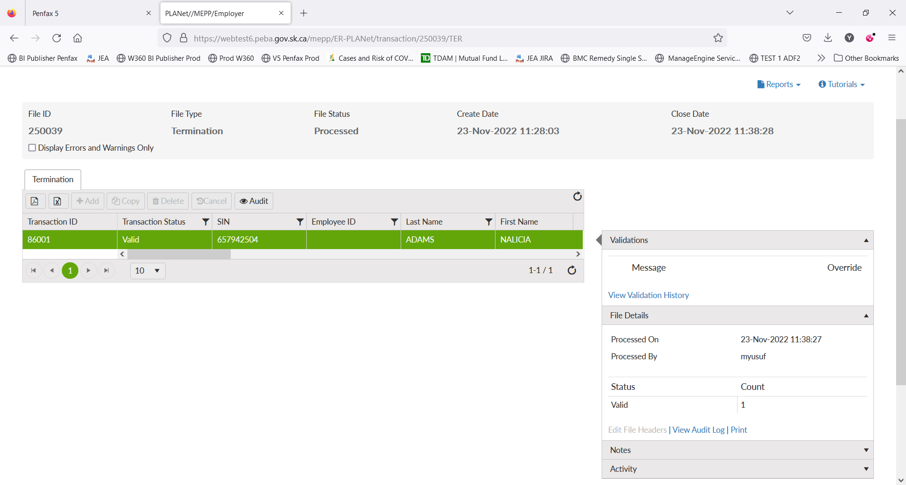

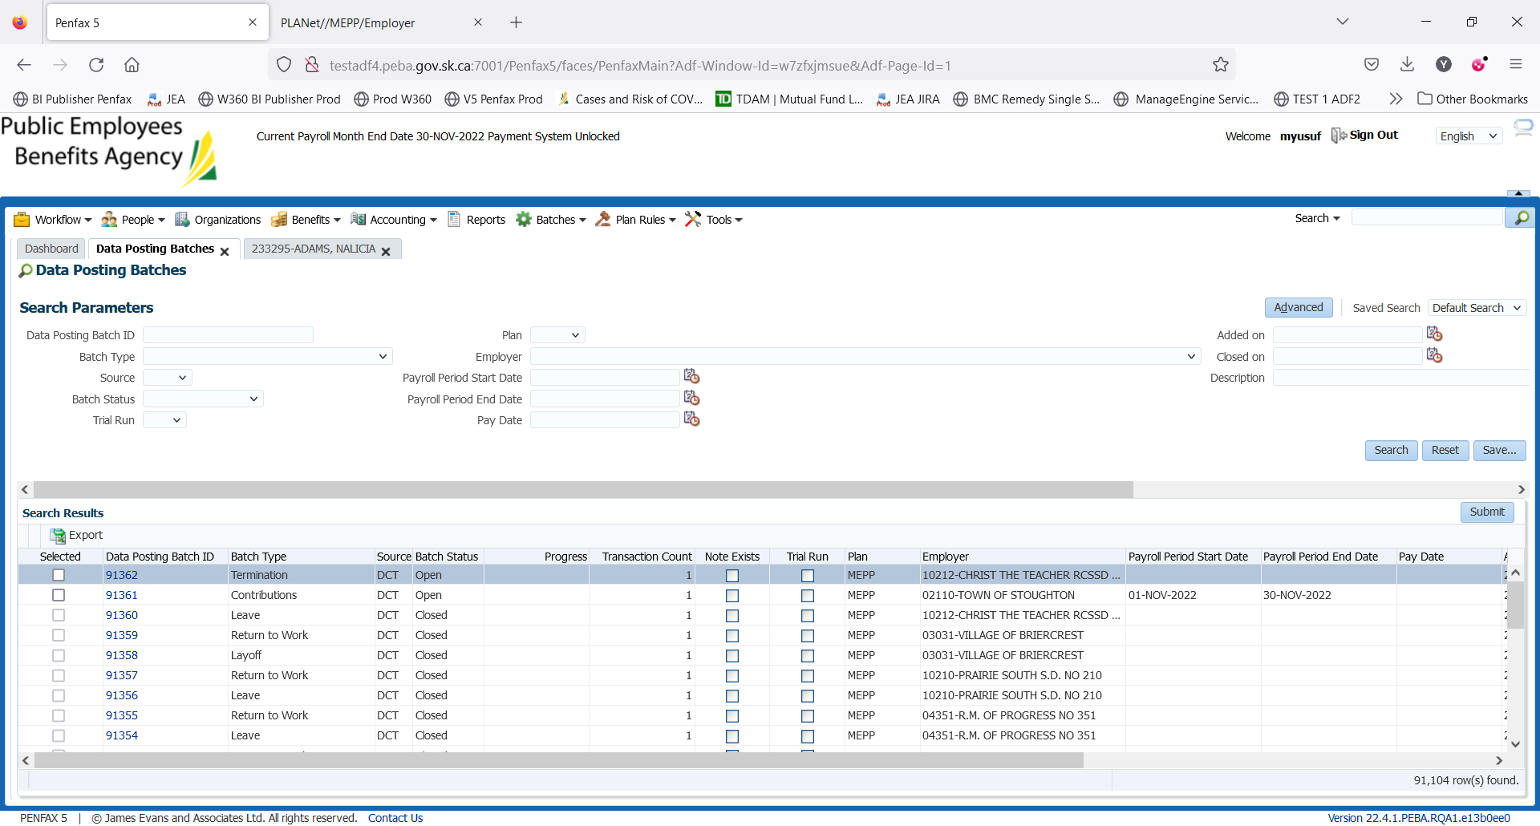

Invalid

Before processing the termination, you need to end the leave.



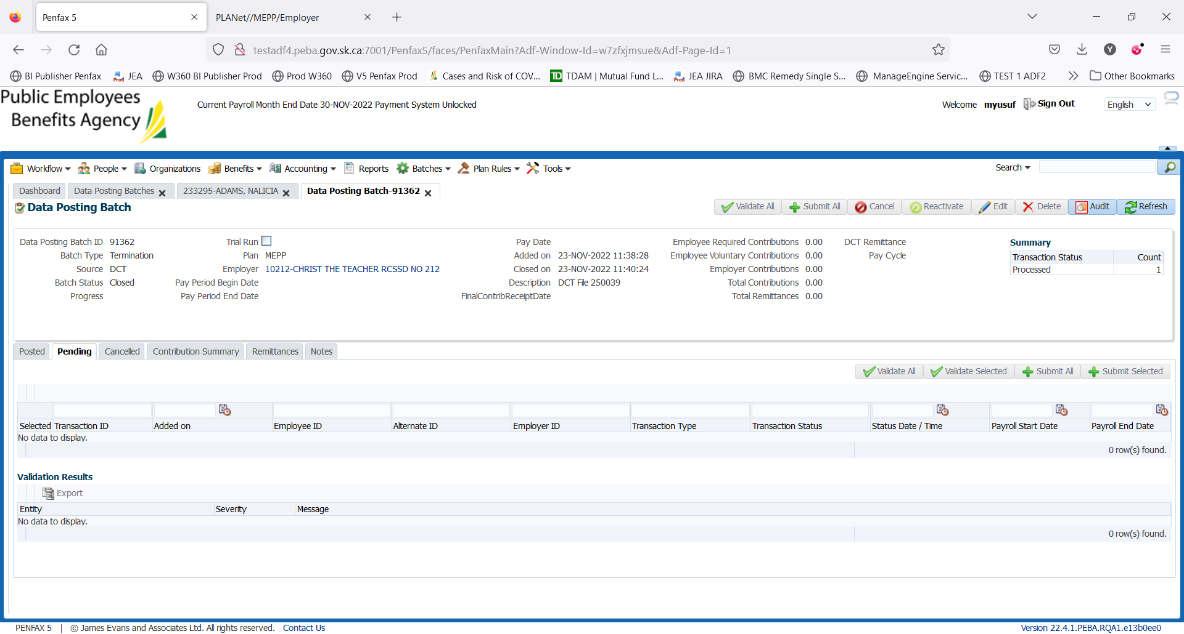

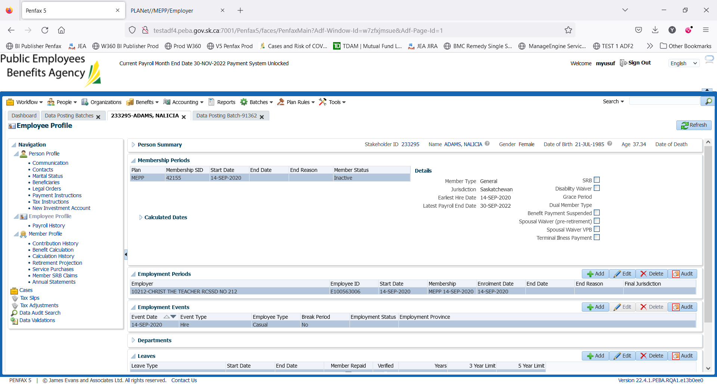

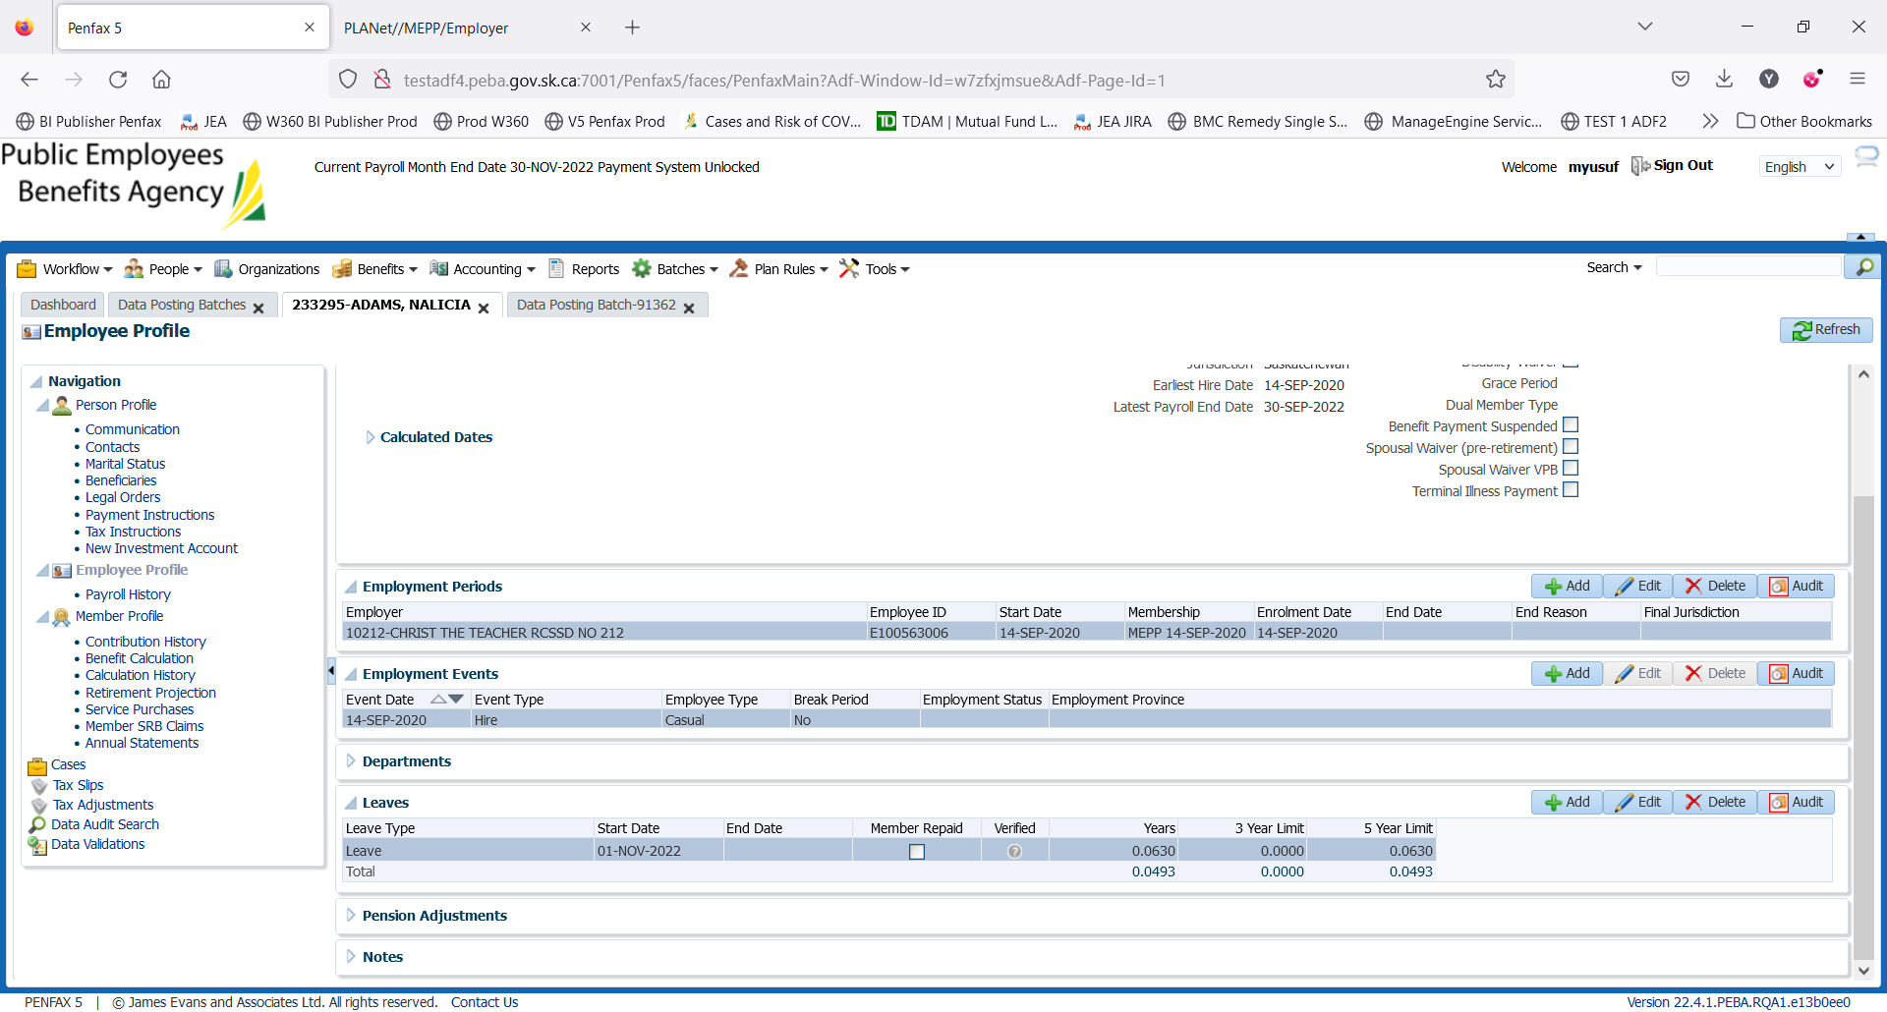

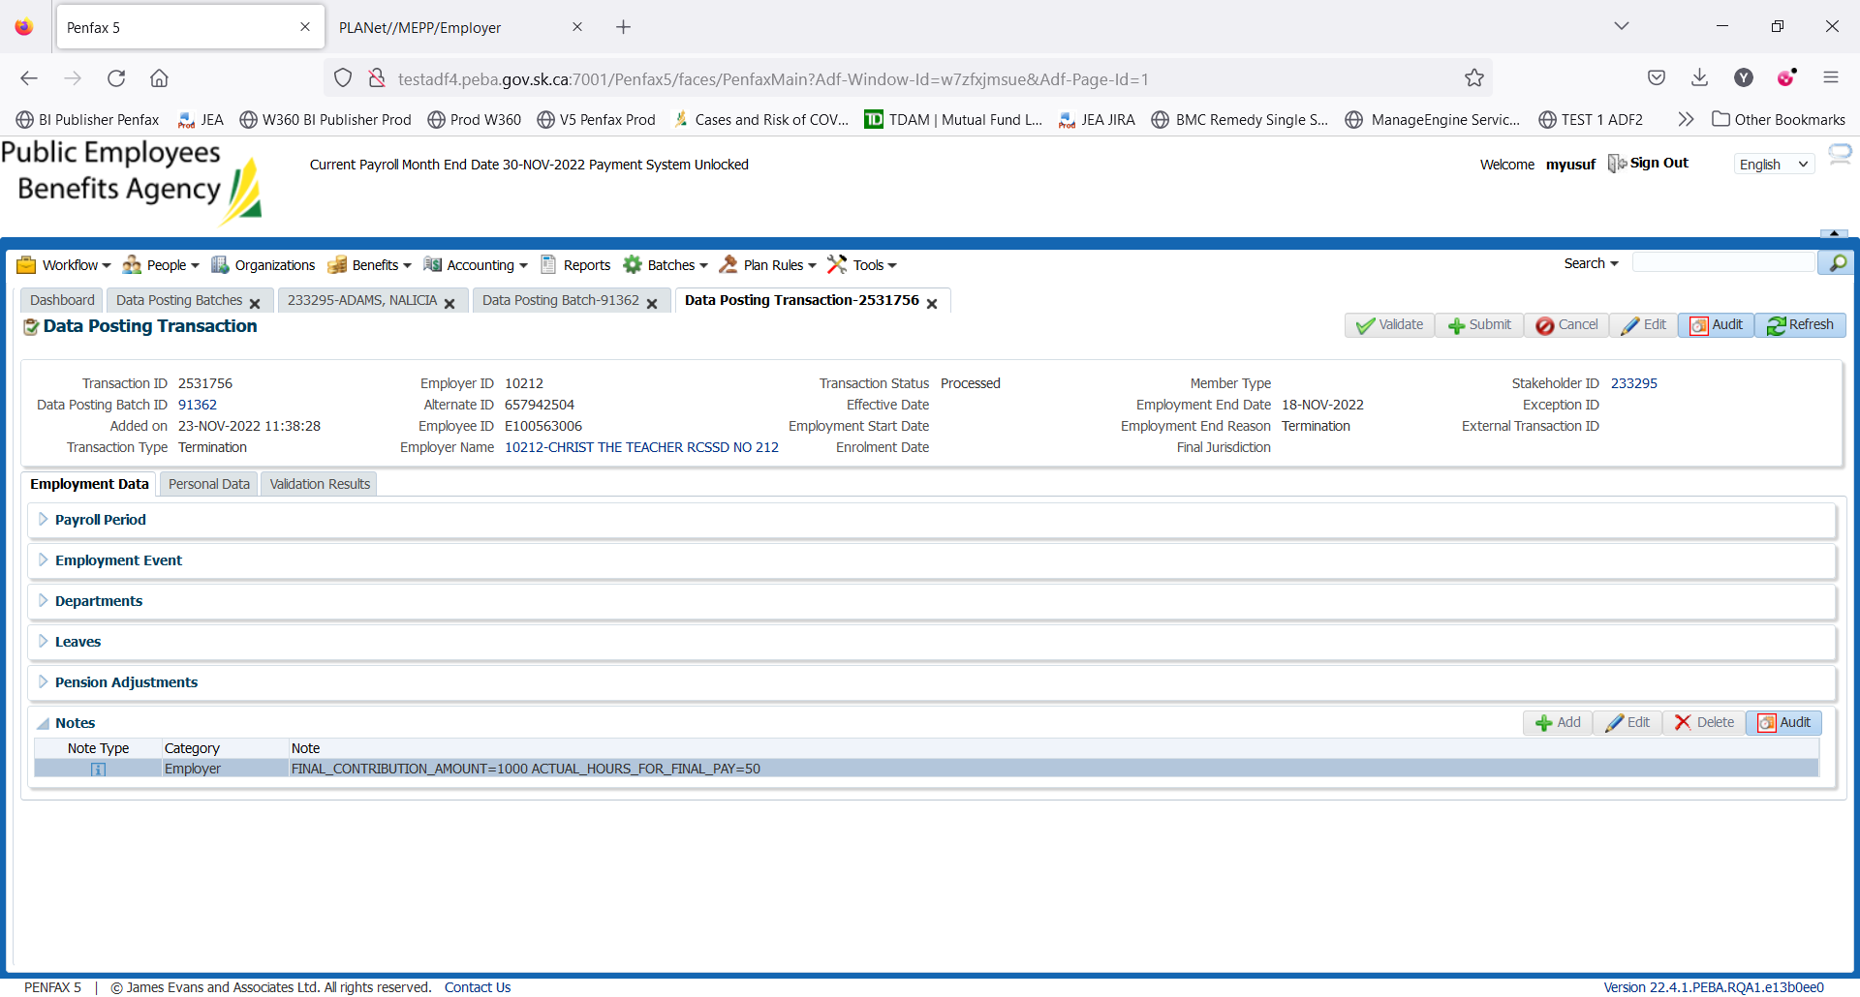

The application is behaving as in production.